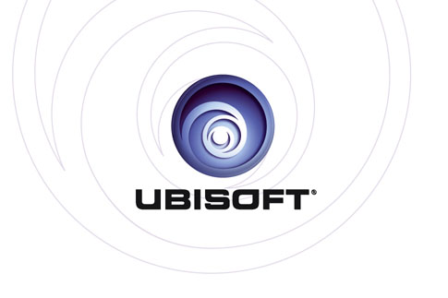
UBISOFT® UNVEILS YOUR SHAPE™: FITNESS EVOLVED EXCLUSIVELY FOR KINECTTM FOR XBOX 360®

Breakthrough Proprietary Player Projection Technology Enhances Next Generation Fitness Experience on Xbox 360

Sydney, Australia - June 15th, 2010 - Today Ubisoft announced that Your Shape™: Fitness Evolved is in development exclusively for KinectTM for Xbox 360® video game and entertainment system from Microsoft. Developed by Ubisoft Montreal, the game will be available at retail end 2010. Using the power of KinectTM for Xbox 360® and Ubisoft’s proprietary Player Projection technology, Your Shape™: Fitness Evolved will give players full control of their fitness experience through voice and body motions. Your Shape™: Fitness Evolved will deliver a dynamic, interactive and convenient at-home workout tailored to each player’s individual fitness goals. The combination of KinectTM for Xbox 360® with Ubisoft’s Player Projection technology will provide the player with unprecedented precision, feedback and results.

“Ubisoft’s Your Shape™: Fitness Evolved leverages the interactivity of KinectTM for Xbox 360® to revolutionise fitness gaming,” said Felicia Williams, international brand manager at Ubisoft. “Your Shape™: Fitness Evolved is so precise, fun and interactive that players won’t even realise that they are getting a great workout while playing our game.”

Ubisoft’s Player Projection technology is a trailblazer for KinectTM for Xbox 360®. The player’s real silhouette is projected on screen, not through an Avatar, making the player the main focus of the experience. The player’s real body is tracked during the training session, enabling the game to give direct feedback, telling the player if they have reached the optimal position for the most efficient and immersive fitness experience ever.

Players will have the freedom to choose how they want to play and interact with Your Shape™: Fitness Evolved. They have the choice of working with a personal trainer, taking a variety of classes or getting the entire family involved with fun mini-games, such as dancing and target practice. At the start of the game, players will complete a fitness test and will be asked to input their goals. The game will offer players a complete fitness program fully adapted to their goals and capabilities. The fitness program will evolve and change as a players’ fitness level improves, keeping them motivated and challenged.

Players will also have the opportunity to work out with some of the best personal trainers in the industry in the comfort of their own homes without the cost of a gym membership. Michael George, Los Angeles–based celebrity fitness trainer and Michelle Bridges, trainer for all five series on Australia’s “The Biggest Loser,” will both offer workout classes at launch. There are also a variety of fitness class options, including yoga, Pilates, martial arts and boxing. In addition, Your Shape™: Fitness Evolved will also offer a wide choice of mini-games including dancing, ball games, balance games and hula-hoop. The mini games support turn-based multiplayer mode so players can challenge friends and family.

KinectTM for Xbox 360® puts you at the center of your favorite entertainment experiences, including fitness," said Matt Barlow, general manager of IEB marketing for Microsoft. "The precision of the Kinect sensor will transform your workout routine by making you the controller, taking technology out of your hands to allow you to get fit and have fun in the most natural way possible."

Your Shape’s online fitness portal will allow players to track and share all their workout data and will provide a centralised location for all fitness, wellness and training needs. It will host a thriving community where users can share their fitness challenges, interact with groups and stay inspired and engaged. Your Shape™: Fitness Evolved will also offer new content online available on Xbox LIVE® Marketplace for the Xbox 360® video game and entertainment system from Microsoft to refresh and continually develop players’ workout experiences.
For more information on Your Shape™: Fitness Evolved, please visit: www.yourshapegame.com

- ENDS -
Media Contact:
Anna Chance
PR and Promotions
p: 02 8587 1813
e: anna.chance@ubisoft.com
For further information please register at the Australian Press Extranet: http://aussiepress.ubi.com/
About Ubisoft:
Ubisoft is a leading producer, publisher and distributor of interactive entertainment products worldwide and has grown considerably through a strong and diversified line-up of products and partnerships. Ubisoft has offices in 26 countries and has sales in more than 55 countries around the globe. It is committed to delivering high-quality, cutting-edge video game titles to consumers. For the 2009-10 fiscal year Ubisoft generated sales of € 871 million. To learn more, please visit: www.ubisoftgroup.com.

© 2010 Ubisoft Entertainment. All Rights Reserved. Your Shape logo, Ubisoft, and the Ubisoft logo are trademarks of Ubisoft Entertainment in the U.S. and/or other countries. Microsoft, Xbox, Xbox 360, Xbox LIVE, and the Xbox logos are trademarks of the Microsoft group of companies and are used under license from Microsoft.

